**BANK LOAN REPORT QUERY DOCUMENT**

1. **BANK LOAN REPORT | SUMMARY**

**KPI’s:**

**Total Loan Applications**

*SELECT COUNT(id) AS Total_Applications FROM bank_loan_data*



**MTD Loan Applications**

SELECT COUNT(id) AS Total_Applications FROM bank_loan_data

WHERE MONTH(issue_date) = 12



**PMTD Loan Applications**  
*SELECT COUNT(id) AS Total_Applications FROM bank_loan_data*

*WHERE MONTH(issue_date) = 11*



**Total Funded Amount**

*SELECT SUM(loan_amount) AS Total_Funded_Amount FROM bank_loan_data*



**MTD Total Funded Amount**

*SELECT SUM(loan_amount) AS Total_Funded_Amount FROM bank_loan_data*

*WHERE MONTH(issue_date) = 12*



**PMTD Total Funded Amount**

*SELECT SUM(loan_amount) AS Total_Funded_Amount FROM bank_loan_data*

*WHERE MONTH(issue_date) = 11*

**Total Amount Received**

*SELECT SUM(total_payment) AS Total_Amount_Collected FROM bank_loan_data*



**MTD Total Amount Received**

*SELECT SUM(total_payment) AS Total_Amount_Collected FROM bank_loan_data*

*WHERE MONTH(issue_date) = 12*



**PMTD Total Amount Received**

*SELECT SUM(total_payment) AS Total_Amount_Collected FROM bank_loan_data*

*WHERE MONTH(issue_date) = 11*



**Average Interest Rate**

*SELECT AVG(int_rate)*100 AS Avg_Int_Rate FROM bank_loan_data*



**MTD Average Interest**

*SELECT AVG(int_rate)*100 AS MTD_Avg_Int_Rate FROM bank_loan_data*

*WHERE MONTH(issue_date) = 12*



**PMTD Average Interest**

*SELECT AVG(int_rate)*100 AS PMTD_Avg_Int_Rate FROM bank_loan_data*

*WHERE MONTH(issue_date) = 11*



**Avg DTI**

*SELECT AVG(dti)*100 AS Avg_DTI FROM bank_loan_data*



**MTD Avg DTI**

*SELECT AVG(dti)*100 AS MTD_Avg_DTI FROM bank_loan_data*

*WHERE MONTH(issue_date) = 12*



**PMTD Avg DTI**

*SELECT AVG(dti)*100 AS PMTD_Avg_DTI FROM bank_loan_data*

*WHERE MONTH(issue_date) = 11*



**GOOD LOAN ISSUED**

**Good Loan Percentage**

*SELECT*

*(COUNT(CASE WHEN loan_status = 'Fully Paid' OR loan_status = 'Current' THEN id END) * 100.0) /*

*COUNT(id) AS Good_Loan_Percentage*

*FROM bank_loan_data*



**Good Loan Applications**

*SELECT COUNT(id) AS Good_Loan_Applications FROM bank_loan_data*

*WHERE loan_status = 'Fully Paid' OR loan_status = 'Current'*



**Good Loan Funded Amount**

*SELECT SUM(loan_amount) AS Good_Loan_Funded_amount FROM bank_loan_data*

*WHERE loan_status = 'Fully Paid' OR loan_status = 'Current'*



**Good Loan Amount Received**

*SELECT SUM(total_payment) AS Good_Loan_amount_received FROM bank_loan_data*

*WHERE loan_status = 'Fully Paid' OR loan_status = 'Current'*



**BAD LOAN ISSUED**

**Bad Loan Percentage**

*SELECT*

*(COUNT(CASE WHEN loan_status = 'Charged Off' THEN id END) * 100.0) /*

*COUNT(id) AS Bad_Loan_Percentage*

*FROM bank_loan_data*



**Bad Loan Applications**

*SELECT COUNT(id) AS Bad_Loan_Applications FROM bank_loan_data*

*WHERE loan_status = 'Charged Off'*



**Bad Loan Funded Amount**

*SELECT SUM(loan_amount) AS Bad_Loan_Funded_amount FROM bank_loan_data*

*WHERE loan_status = 'Charged Off'*



**Bad Loan Amount Received**

*SELECT SUM(total_payment) AS Bad_Loan_amount_received FROM bank_loan_data*

*WHERE loan_status = 'Charged Off'*



**LOAN STATUS**

*SELECT*

*loan_status,*

*COUNT(id) AS LoanCount,*

*SUM(total_payment) AS Total_Amount_Received,*

*SUM(loan_amount) AS Total_Funded_Amount,*

*AVG(int_rate * 100) AS Interest_Rate,*

*AVG(dti * 100) AS DTI*

*FROM*

*bank_loan_data*

*GROUP BY*

*loan_status*

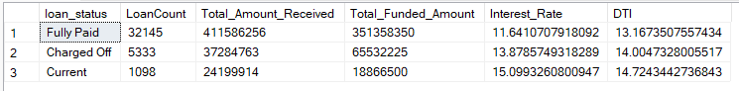

*SELECT*

*loan_status,*

*SUM(total_payment) AS MTD_Total_Amount_Received,*

*SUM(loan_amount) AS MTD_Total_Funded_Amount*

*FROM bank_loan_data*

*WHERE MONTH(issue_date) = 12*

*GROUP BY loan_status*

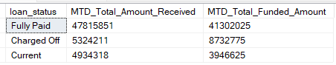

1. **BANK LOAN REPORT | OVERVIEW**

**MONTH**

*SELECT*

*MONTH(issue_date) AS Month_Munber,*

*DATENAME(MONTH, issue_date) AS Month_name,*

*COUNT(id) AS Total_Loan_Applications,*

*SUM(loan_amount) AS Total_Funded_Amount,*

*SUM(total_payment) AS Total_Amount_Received*

*FROM bank_loan_data*

*GROUP BY MONTH(issue_date), DATENAME(MONTH, issue_date)*

*ORDER BY MONTH(issue_date)*

**STATE**

*SELECT*

*address_state AS State,*

*COUNT(id) AS Total_Loan_Applications,*

*SUM(loan_amount) AS Total_Funded_Amount,*

*SUM(total_payment) AS Total_Amount_Received*

*FROM bank_loan_data*

*GROUP BY address_state*

*ORDER BY address_state*

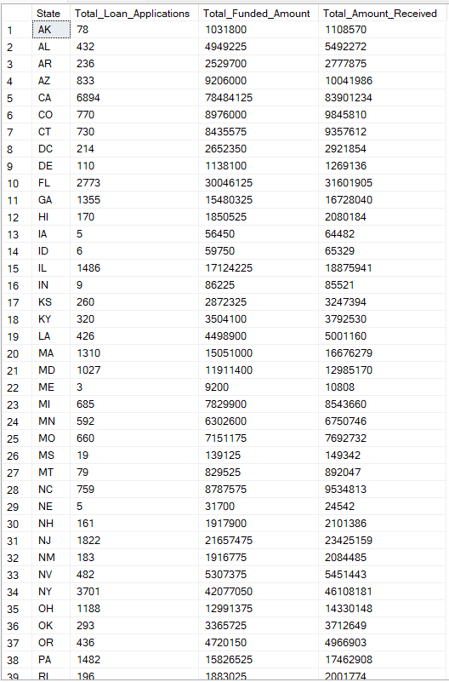

**TERM**

*SELECT*

*term AS Term,*

*COUNT(id) AS Total_Loan_Applications,*

*SUM(loan_amount) AS Total_Funded_Amount,*

*SUM(total_payment) AS Total_Amount_Received*

*FROM bank_loan_data*

*GROUP BY term*

*ORDER BY term*

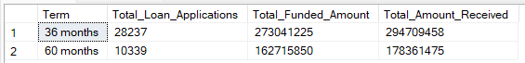

***EMPLOYEE LENGTH***

*SELECT*

*emp_length AS Employee_Length,*

*COUNT(id) AS Total_Loan_Applications,*

*SUM(loan_amount) AS Total_Funded_Amount,*

*SUM(total_payment) AS Total_Amount_Received*

*FROM bank_loan_data*

*GROUP BY emp_length*

*ORDER BY emp_length*

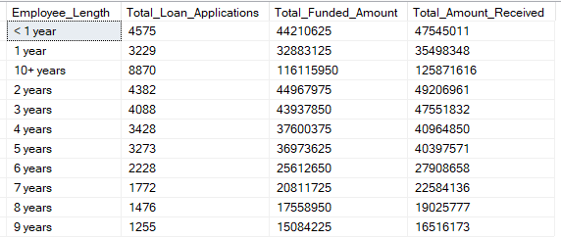

**PURPOSE**

*SELECT*

*purpose AS PURPOSE,*

*COUNT(id) AS Total_Loan_Applications,*

*SUM(loan_amount) AS Total_Funded_Amount,*

*SUM(total_payment) AS Total_Amount_Received*

*FROM bank_loan_data*

*GROUP BY purpose*

*ORDER BY purpose*

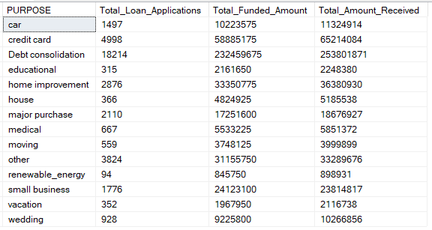

**HOME OWNERSHIP**

*SELECT*

*home_ownership AS Home_Ownership,*

*COUNT(id) AS Total_Loan_Applications,*

*SUM(loan_amount) AS Total_Funded_Amount,*

*SUM(total_payment) AS Total_Amount_Received*

*FROM bank_loan_data*

*GROUP BY home_ownership*

*ORDER BY home_ownership*

